Professor Robert F Care AM BE PhD FREng HonFIEAust FTSE FRSN CPEng EngExec NER APEC Engineer IntPE(Aus)
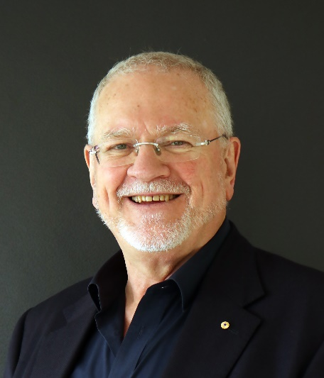
Robert is a Director of Care Collaborative Pty Ltd (https://care-collaborative.com.au/ ), focussed on strategic infrastructure advice, coaching and mentoring senior people, and on developing high performance business and project teams. He is a Consultant Principal to engineering firm Arup Group (https://arup.com ) and he also holds the position of Professor of Practice at University of New South Wales, Sydney (Robert Care | UNSW Engineering). In the For-Purpose (aka Not for Profit) sector Robert is Chair of RedR Australia (https://www.redr.org.au/ ) and RedR International, Immediate past Chair of the Steering Committee of the Community of Practice for Humanitarian Engineering (Engineers Australia) (https://humeng.engineersaustralia.org.au/ ) and Chair of Common Purpose Asia Pacific (https://commonpurpose.org/locations/common-purpose-singapore/about-common-purpose-singapore/ ).
Most recently he is the recently retired Independent Chair of the City Precinct Infrastructure Steering committee providing coordination of infrastructure provision in Canberra’s CBD for the ACT Government; Immediate past Chair of the Canberra Division College of Leadership and Management Engineers Australia; a recently retired member of University of Canberra’s Planning and Development Committee.
His experience includes being a Director/Principal in the Arup Group (a globally recognised engineering firm) for 37 years. He was a member of the Arup Global Group Board from 2008 to 2014, Chair of Arup Group’s UK, Middle East, and Africa region from 2010 to 2013, and Chair of Arup Group’s Australasia Region from 2004 to 2010. He has lived and worked in the UK, HK, Papua New Guinea, Japan, and Australia. He continues to consult to Arup Group.
From 1986 to 1988 he was the Chief Engineer of the NCDC and then through the transition to self-government and until 1990 he was the head of Public Works in the ACT.
Robert was a Director of RedR Australia, a provider of Humanitarian Services throughout the world from 2006 to 2011 (Chair from 2008 to 2011) and Director of Common Purpose Charitable Trust (UK) from 2013 to 2020 (Chair 2013 to 2014). Robert was reappointed as a Director of RedR Australia in Oct 2019 and Chair in May 2020 and he became Chair of RedR International in June 2021. He is a Director of Common Purpose Asia Pacific (2015-present).
In 2012 Robert was made a Member of the Order of Australia AM for his services to Engineering, Business, Humanitarian Programs and Athletics. In 2013 Robert was recognised by the University of New South Wales as International Alumni of the Year. In 2014 Engineers Australia awarded Robert NSW and later Australian Professional Engineer of the Year. In 2015 Robert was made a Fellow of the Royal Academy of Engineering UK. In 2018 Robert was made an Honorary Fellow of the Engineers Australia. In 2020 he was admitted as a Fellow of the Royal Society of NSW.
He lives in Canberra with his wife Kerry. His children (Alison and Gareth) and grandchildren (Elyse, Hazel and Olive) live in Sydney. Kerry and he enjoy (or used to enjoy travel) and driving his 1968 MGB.

