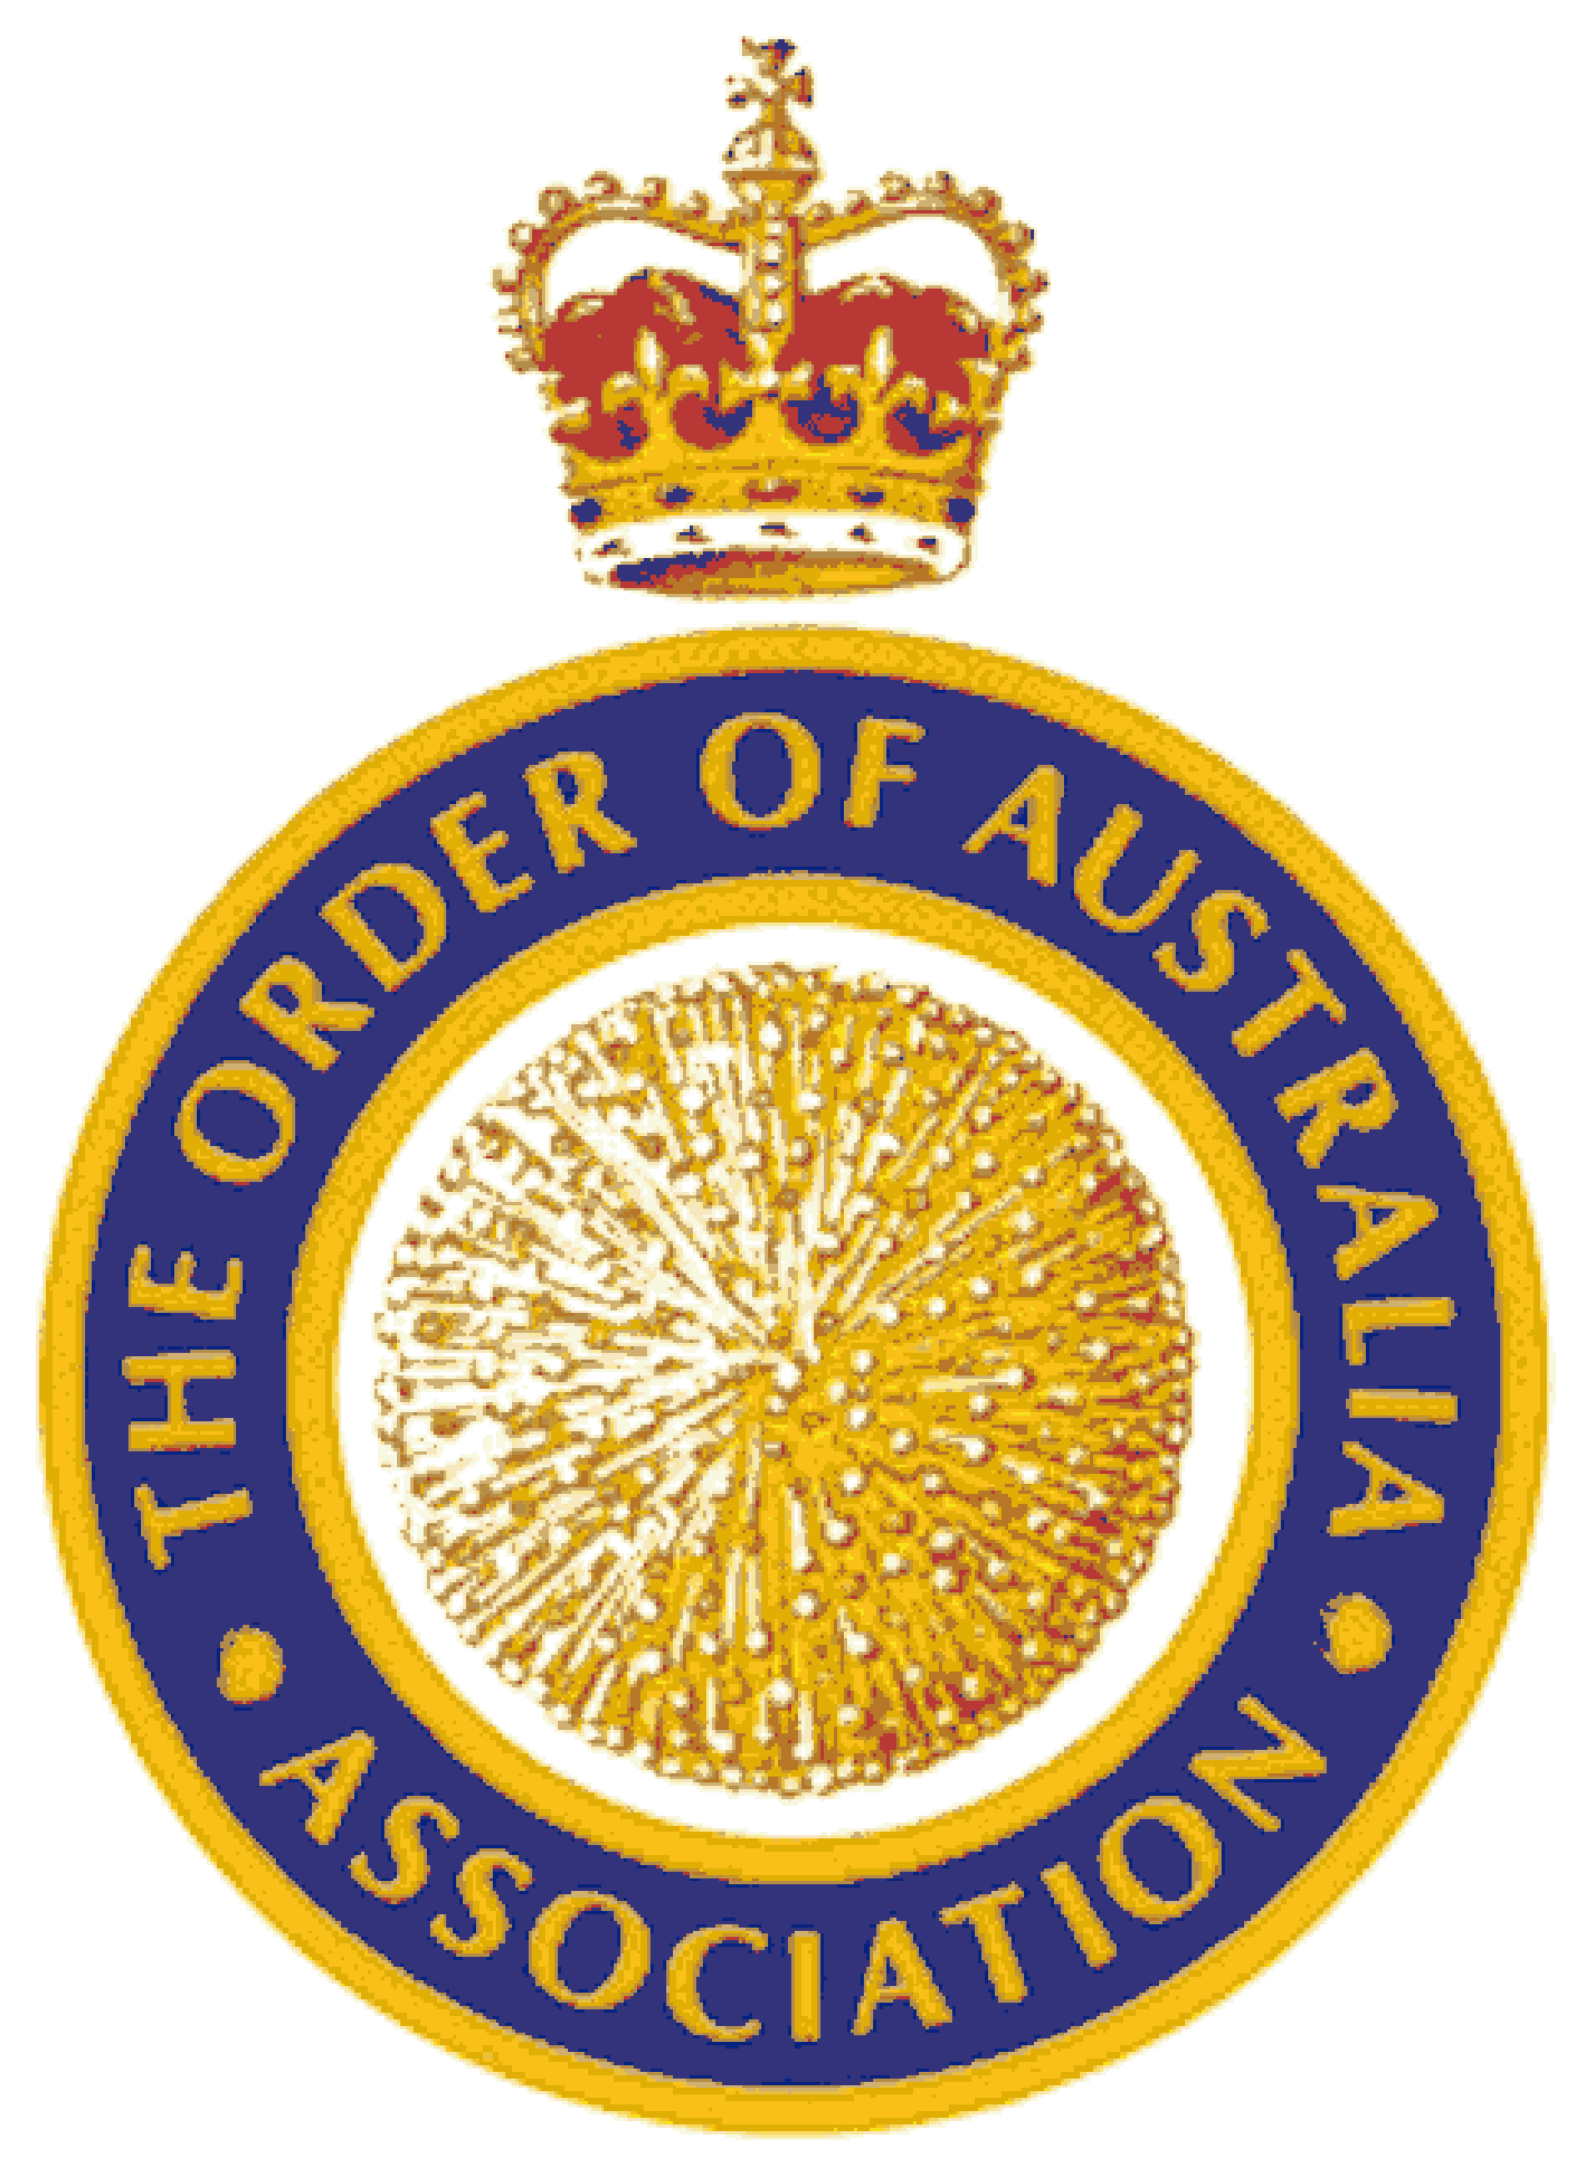
THE ORDER OF AUSTRALIA – TIMELINE
14 FEBRUARY
2025
50 YEARS
14 FEBRUARY 1975
FORMAL APPROVAL
Of Australian Honours
JUNE 1975
FIRST HONOURS LIST - QB
JANUARY 1990
END OF
IMPERIAL HONOURS
JUNE 1976
KNIGHTS / DAMES / MEDALS INTRODUCED
APRIL 1977
FIRST INVESTITURE BY QUEEN
OCTOBER 1977
INVESTITURES BY GG FOR 1976 / 1977
TRADITIONALLY
IMPERIAL HONOURS
JANUARY 1978
INVESTITURES BY GG & STATE GOVERNORS

1972
2025

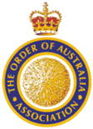
THE ORDER OF AUSTRALIA – TIMELINE
TRADITIONALLY  IMPERIAL HONOURS | Prior to the suggestion for an ‘Australian System of Honours’ by then Prime Minister Gough Whitlam, in 1972, recognition had been via the Imperial Honours. Nominations came from mainly Federal and State Governments through GG & Governors.
14 FEBRUARY 1975  FORMAL APPROVAL Of Australian Honours | Her Majesty the Queen formally approved the Letters Patent for The Order of Australia.  See www.gg.gov.au for details.
JUNE 1975  FIRST HONOURS LIST - QB | The first Order of Australia Honours List was issued for the Queen’s Birthday in June 1975.  106 Australians were honoured, 6 Companions, 8 Officers and 92 Members.
APRIL 1977  FIRST INVESTITURE BY QUEEN | During The Queen’s Silver Anniversary tour of 1977, she personally invested the original 106 New Recipients at Government House Yarralumla.
OCTOBER 1977  INVESTITURES BY GG FOR 1976 / 1977 | The New Recipients on four remaining Honours Lists AD76, QB76, AD77 and QB77 were invested by the GG during a tour of each State & Territory, plus Katherine and Alice Springs.
JANUARY 1978  INVESTITURES BY GG & STATE GOVERNORS | After the Investitures by The Queen & the GG to clear the backlog, arrangements were made for the GG and State Governors and the Administrator of the NT to conduct investitures.
JANUARY 1990  END OF  IMPERIAL HONOURS | Gradually, recognition of Australians increased within the Order of Australia. There were no nominations for New Year Imperial Honours for 1990.  The Queen suggested that from this time all Honours should be within the Australian Honours System.

